Provider Manual
Patient Engagement Program North Dakota Medicaid Expansion Sanford Health Plan

About The Patient

Patient Engagement Program

Copyright 2015
North Dakota Pharmacy Service Corporation
1641 Capitol Way
Bismarck, ND 58501-5600
Phone 701.258.4922 • Fax 701.258.9312

All rights reserved. No part of this manual may be photocopied or reproduced in any form without written permission form the publisher. Moreover, no part of this publication can be stored in a retrieval system, transmitted by any means, or recorded or otherwise, without written permission from the publisher.

Limits of Liability and Disclaimer of Warranty
While ever precaution has been taken in preparing this manual, including research, development, and testing the publisher and author assume no responsibility for errors or omissions. No liability is assumed by either publisher or author for damages resulting in the use of this information.

Printed in the United States of America

Acknowledgement

Pharmacists in North Dakota have a long legacy of providing innovative initiatives to improve patient care. Some of these innovations have involved CLIA waived clinical testing to improve access for screening and monitoring of blood sugar, cholesterol and INRs. To continued access to care in rural areas through telepharmacy services.
About the Patient would like to acknowledge the members of the North Dakota Pharmacy Association (NDPhA)/North Dakota Pharmacy Services Corporation (NDPSC) and North Dakota Board of Pharmacy for their dedication and resources in support of the vision to provide face-to-face Medication Therapy Management Services by pharmacists in North Dakota.
A special thank you goes out to Michael Schwab for his continued dedication and networking with rural pharmacists, legislators, and insurers in order to establish mechanisms for pharmacists to provide pharmacotherapy services to patients.
A special thank you goes out to Jayme Steig for his ingenuity in the establishment of the About The Patient program and electronic clinical documentation system MTM Express.

Table of Contents
Welcome 1
Pre-requisite Skills 1
Background 2
Program Expectations 3
Documentation Requirements for All Patient Encounters 4
Patient Demographics and Eligibility (Insurance) 4
Medical History 5
Medication Related Problems, Surveys, Evaluation and Billing 6
Antibiotic Adherence 6
Glucose Meter Compliance 6
Synchronized Refill Program 7
Monitor Blood Pressure 7
ACE and ARB Therapy 7
Appendix 1: History Form 8
Appendix 2: Webinar Training 10

Welcome
“Recognition of pharmacists as health care providers, clinicians and an essential part of the health care team is appropriate given the level of care they provide in many health care settings."
- General Regina Benjamin, U.S. Surgeon General

W
e are in an exciting time for pharmacy cognitive services. Since the early 1970’s, pharmacists in various settings have demonstrated their abilities in the provision of cognitive services to positively affect patient’s health. These medication expertises are now being recognized by insurers across the country in the form of disease management and Medication Therapy Management (MTM) billable services. You are now joining in this legacy of health care.

Pre-requisite Skills
This manual is intended to familiarize participants with the documentation requirements for the Sanford Health Plan Patient Engagement Program (PEP). It is assumed that participants are: Employed by an establishment which has a signed network agreement contract with NDPSC, participated in webinar training for the PEP program and have completed the webinar training documentation form (Appendix 2), and that participants have a good working knowledge of Medication Therapy Management based on the most recent standards as outlined by the American Pharmacist Association. Additional questions regarding these pre-requisites may be found on the About The Patient website: www.AboutThePatient.net.

Background

The Affordable Care Act provides states with additional federal funding to expand their Medicaid programs to cover adults under 65 with income up to 133% of the federal poverty level. Children (18 and under) are eligible up to that income level or higher in all states.
This means that in states that have expanded Medicaid, free or low-cost health coverage is available to people with incomes below a certain level regardless of disability, family status, financial resources, and other factors that are usually taken into account in Medicaid eligibility decisions. Persons who make up to $16,105 a year for 1 person ($32,913 for a family of 4), will most likely now qualify for Medicaid coverage.
North Dakota is one of the states that has decided to expand its Medicaid program. North Dakota Medicaid has contracted with Sanford Health Plan to administer this program.

Sanford Health Plan recognizes the importance and need for programs, services and activities which advance the practice of pharmacy, provide a high level of patient care, and help to control health care costs. They have partnered with the North Dakota Pharmacy Services Corporation for the provision of the Patient Engagement Program for Medicaid expansion eligible participants.

Program Expectations
The Patient Engagement Program (PEP) is comprised of either/or face-to-face (preferred) or telephonic, individualized assessment of medication needs and use provided directly by the pharmacist. In providing services, the pharmacist will work with the member and physician or other caregiver to establish and achieve drug therapy treatment goals, avoid or minimize undesirable medication effects, and improve clinical outcomes.

Participating pharmacists should take reasonable effort to confirm a participant is an eligible Medicaid Expansion Program member by confirming member eligibility with Sanford Health Plan. Pharmacists or their designee (i.e. clerk or technician) can contact 1-855-305-5060 to verify eligibility.

All interventions are to be documented in the North Dakota Pharmacy Services Corporation (NDPSC) MTM Express System. Upon successful, complete documentation NDPSC shall reimburse participating pharmacies for their services. Participating pharmacies will be reimbursed $20.00 per 15 minutes for one reasonable unit of service.

The following are the allowable billable services:

Antibiotic Adherence | Pharmacist calls or visits with member 3 days after an antibiotic is prescribed to see if medication being taken as directed and patient is getting better. | Maximum of 30 minutes.
Glucose Meter Compliance | For each diabetic patient, Pharmacist downloads glucose meter results to evaluate testing compliance. | Maximum of 60 minutes.
Synchronized Refill Program | Pharmacist identifies patients on 3 or more maintenance medications and transitions patients to synchronized refill program. | Maximum of 60 minutes.
Monitor Blood Pressure | Pharmacist gets a blood pressure reading twice a month for patients in the first month after beginning a new prescription or dose change. | Maximum of 30 minutes.
ACE and ARB Therapy | Pharmacist identifies and reviews diabetic patients as to appropriateness of ACE and ARB therapy and follow-up with prescriber on a quarterly basis. | Maximum of 30 minutes.

Documentation Requirements for All Patient Encounters
Documentation of each patient encounter may be initially transcribe via hardcopy document (Appendix 1) but in order to receive reimbursement for services must be completely entered into MTM Express. A pharmacist or their designee (Ex. Pharmacy Technician) may enter patient eligibility, demographic and medical history into MTM Express. All Medication Therapy Management interventions, surveys when appropriate and billing are to be completed and submitted by the pharmacist.

Patient Demographics and Eligibility (Insurance)
The following must be completed for each patient encounter regardless of service.

From the initial log in screen select . The following fields are required:
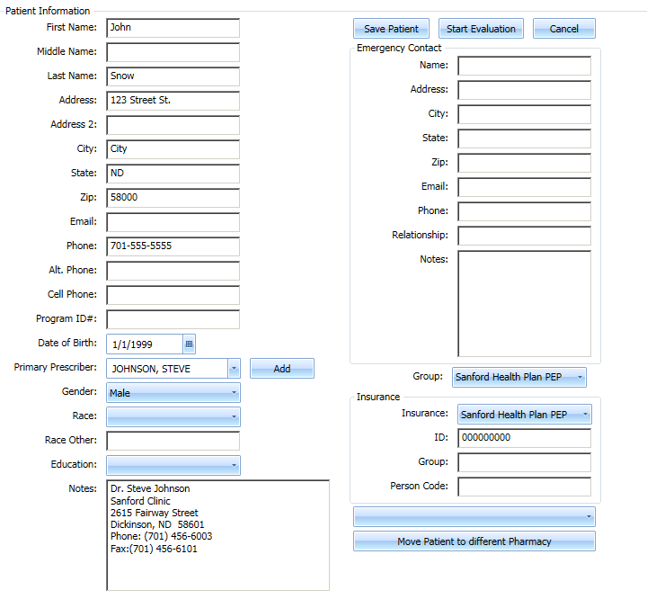

Once information is entered select. To begin entering encounter select .

Medical History
All fields under the health history, pertinent labs, and medications must be completed by pharmacist or designee. All medication directions need to be written out and must be linked to a diagnosis. All over the counter, dietary supplements and herbal products must be listed in medication tab.
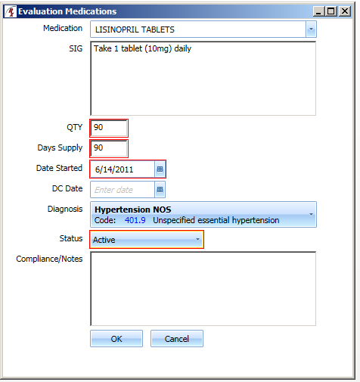

Medication Related Problems, Surveys, Evaluation and Billing
The above tabs are to be completed by the pharmacist.

In the Evaluation tab by selecting the Subjective, Objective, Assessment, and Plan/Prescriber field will pre-populate from the previous tabs. The only free text that is necessary is Plan/Patient. Additional information may be free text into any category as desired.

For billing purposes the required fields: Type of visit, Duration of visit and Date of visit. Anticipated Results is optional.

Once entered select . Any tab missing information will be highlighted in red. Once all information is entered click OK to complete billing.

Antibiotic Adherence
When documenting antibiotic adherence standard documentation as listed above is required with the addition of the button located in the
Surveys tab. Summary of patient counseling and/or outcomes must be
documented in evaluation tab Plan/Patient section.

Glucose Meter Compliance
When documenting glucose meter compliance standard documentation as listed above is required. At least one to two weeks of blood glucose levels is to be documented in the Labs tab. To enter additional blood glucose levels select Miscellaneous Labs: 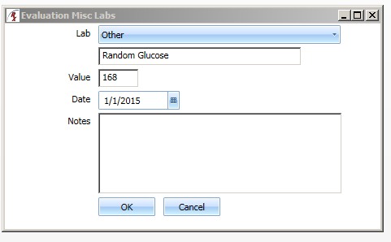.
Summary of patient counseling and/or outcomes must be documented in evaluation tab Plan/Patient section.

Synchronized Refill Program
When documenting synchronization of medications standard documentation as listed above is required. Summary of patient counseling and monthly refill date must be documented in evaluation tab Plan/Patient section.

Monitor Blood Pressure
When documenting blood pressure standard documentation as listed above is required. Along with blood pressure reading the date of when the blood pressure reading was obtained must be recorded in the lab tab. Summary of patient counseling and/or outcomes must be documented in evaluation tab Plan/Patient section.

ACE and ARB Therapy
When documenting ACE and ARB Therapy standard documentation as listed above is required. In the Plan/Patient section compliance or non-compliance must be documented and if non-compliant document: Date ACE/ARB was prescribed, date patient picked up medication, and date prescriber was contacted regarding non-compliance.
Example documentation:
Compliance: Patient is refilling Lisinopril as prescribed.
Non-Compliance: Lisinopril was prescribed by Dr. Johnson on 10/1/2014 and filled 10/3/2014 for 30 days. Patient has not refilled Lisinopril since original fill date. Dr. Johnson contacted 1/1/2015.
NOTE: Notification to the prescriber for non-compliance is on a quarterly bases.

Appendix 1: History Form
Hardcopy can be found in MTM Express under Resources—Forms.
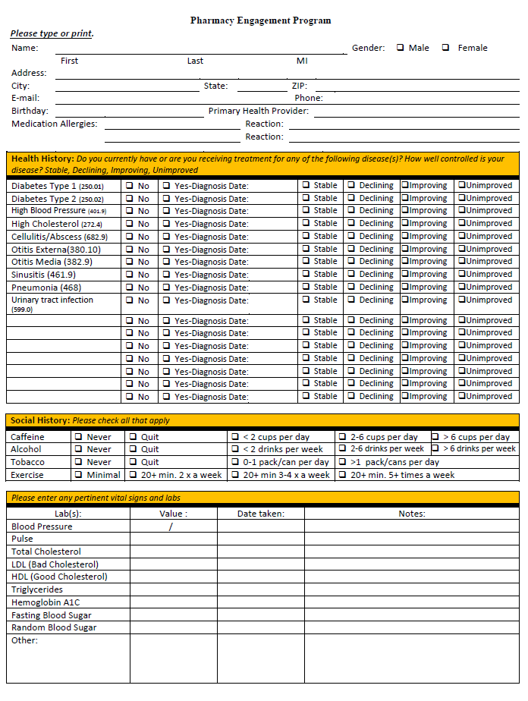

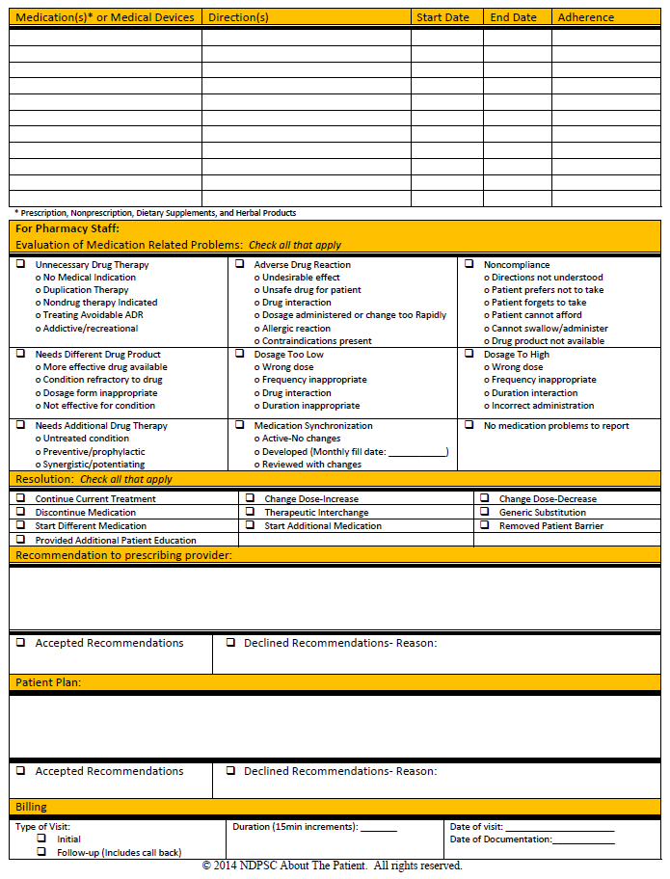

Appendix 2: Webinar Training

Sanford Patient Engagement Program
Medicaid Expansion

Please type or print.
Name:
Home Address:
City: |  |  |  | State: |  |  |  |  |  |  |  |  |  |  | ZIP:
E-mail:
Practice Location(s):
ND Pharmacist license #:
Certification(s) (circle all that apply): |  |  |  |  |  |  | NDPERS: Diabetes/MTM |  |  |  |  |  |  |  |  |  |  |  | WSI: Pain |  |  |  |  | Sanford: PEP
I certify that I have completed the webinar training for the Sanford Patient Engagement Program (PEP) managed by the North Dakota Pharmacy Services Corporation (NDPSC) About The Patient Program. It is my responsibility to identify and confirm patient eligibility for the PEP program. I am fully aware and will adhere to all electronic documentation and billing requirements in order to receive reimbursement for cognitive services rendered to eligible patients.

Signature:__________________________________________ Date:_________________________________

Thank you for participating in the About the Patient Program. Any questions or concerns may be directed to the Program Director. Once form is completed return to the North Dakota Pharmacy Services Corporation by Fax (701) 258-9312, e-mail:ndpha@nodakpharmacy.net or mail: North Dakota Pharmacy Services Corporation, 1641 Capital Way, Bismarck, ND 58501.

